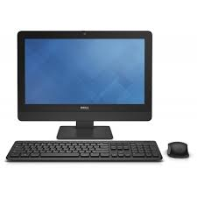

Dell OptiPlex 3030

* Processor Type: Core I3
* Standard Memory:4 GB
* Processor Speed:3.50 GHz
* Screen Size: 19.5 Inches
* **Rs.91,999**